

**School of Computing**

**SRM IST, Kattankulathur – 603 203**

**Course Code: 18CSC206J**

**Course Name: Software Engineering and Project Management**

|  |  |
| --- | --- |
| **Experiment No** | 5 |
| **Title of Experiment** | Prepare Work breakdown structure, Timeline chart, Risk identification table |
| **Name of the candidate** | Alankriti Dadlani |
| **Team Members** | Sanjay, Aritra Karar |
| **Register Number** | RA2111028010010 |
| **Date of Experiment** | 10/03/2023 |

**Mark Split Up**

|  |  |  |  |  |  |
| --- | --- | --- | --- | --- | --- |
| **S.No** |  | **Description** |  | **Maximum Mark** | **Mark Obtained** |
| 1 | Exercise |  |  | 5 |  |
| 2 | Viva |  |  | 5 |  |
|  |  |  | **Total** | **10** |  |

**Staff Signature with date**

# Aim

To Prepare Work breakdown structure, Timeline chart and Risk identification table

**Team Members:**

|  |  |  |  |
| --- | --- | --- | --- |
| **Sl No** | **Register No** | **Name** | **Role** |
| **1** | RA2111028010020 | Aritra Karar | **Rep** |
| **2** | RA2111028010010 | Alankriti Dadlani | **Member** |
| **3** | RA2111028010012 | Sanjay P | **Member** |

# WBS – Examples

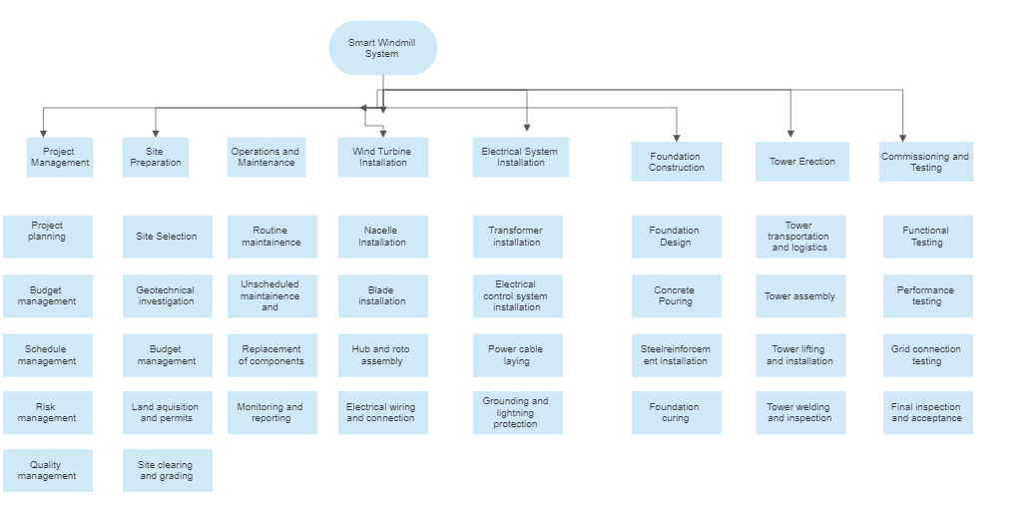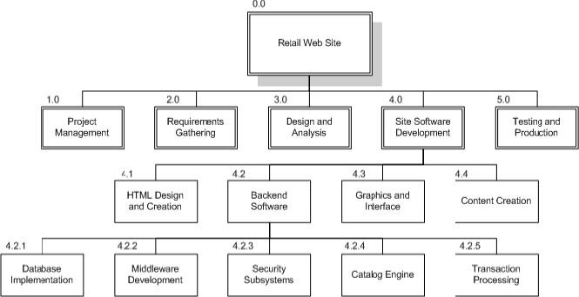

# TIMELINE – GANTT CHART

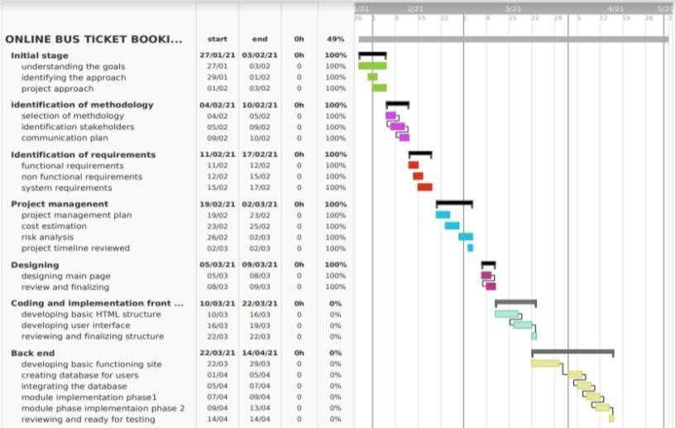

# RISK ANALYSIS – SWOT & RMMM

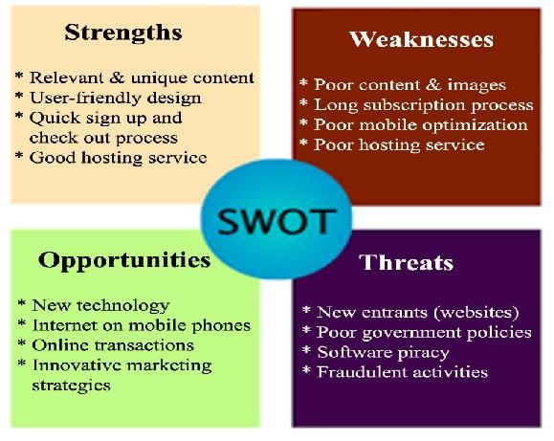

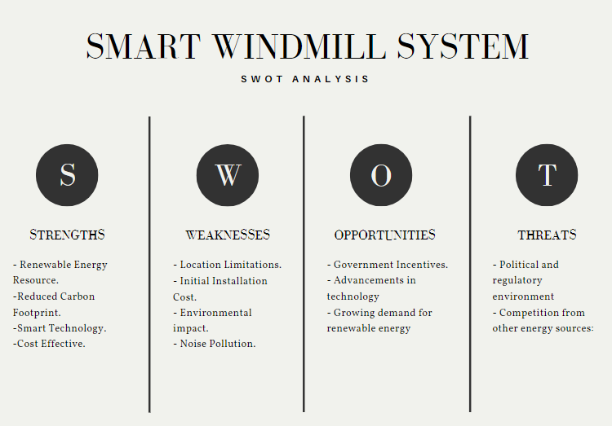 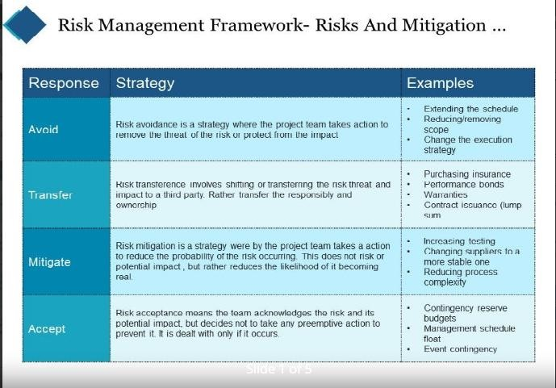

|  |
| --- |
|  |

|  |  |  |  |
| --- | --- | --- | --- |
| Risk | Impact | Likelihood | Mitigation Strategy |
| Delays in regulatory approval for the windmill project | High | Medium | Maintain open communication with regulators and local authorities to ensure compliance with all regulations. Have contingency plans in place to mitigate schedule risks. |
| Weather-related delays during windmill installation | High | High | Monitor weather forecasts closely and schedule installation activities accordingly. Have backup installation teams and equipment on standby in case of delays. |
| Cost overruns due to unexpected expenses | High | Medium | Monitor project expenses closely and have contingency plans in place to manage unexpected costs. Develop a risk management plan and have a reserve budget to cover unforeseen expenses. |

Result:

Thus, the work breakdown structure with timeline chart and risk table were formulated successfully.